**ARTIFICIAL INTELLIGENCE ASSIGNMENT I**

ELIAS KARIUKI – SCT221-0270/2017 - ENTERTAINMENT

MICHELLE KYALO - SCT221-0270/2017 - SMART CITIES

MARVIN KIHATO - SCT221-0270/2017 -INTELLIGENT HOMES

KELVIN GATIMU - SCT221-0270/2017 - ENERGY EFFICIENT BUILDING

GEOFFREY NJENGA - SCT221-0270/2017 - ENERGY EFFICIENT BUILDING

The various ways in which AI has been used greatly in the entertainment industry include:

* **Moderation-** the choice of what content is suitable for viewing in certain countries whether it meets the specifications of the quality content of the country
* **Personalization/ content classification-** apps like Spotify or Netflix use special algorithms to give users their content preferences using algorithms from their viewing habits



* **Sports broadcasting-** AI can be trained to identify objects and actions in sports events giving deeper insights
* **Gaming –** Non-player characters(NPCs) controlled by AI use algorithms to identify changes in player behaviors and reactions to different scenarios and therefore makes the NPCs make games more challenging and interesting
* **Automated subtitles-** using natural language processing, AI can understand speech and translate to subtitles in any language and to be in synch with lip movements in films

**Smart Cities.**

A smart city is a city that makes use of information and technologies to enhance the quality and performance of urban services like energy and transportation reducing the consumption of resources, preventing wastage, and overall costs. Smart cities possess ICT and also employ technology in a way that improves the lives of citizens in a smart city. The use of AI-enabled IoT can address key challenges posed by an excessive urban population which includes traffic management, healthcare, energy crises etc.

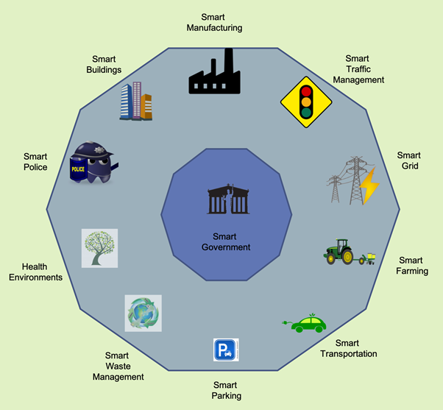

**Smart** **Traffic** **Management**.

There are traffic solutions in AI and IoT that can be implemented to ensure the inhabitants of a smart city get from one point to another safely and efficiently.

**Smart** **Parking**.

Road surface sensors can be embedded on parking spots to determine whether a spot is free or occupied. This reduces drivers waiting time ad congestion.

**Smart** **Waste** **Management**

Artificial Intelligence can be adopted for smart recycling and waste management and can provide a suitable system.

**Smart** **Policing**.

There is need for smart policing in smart cities since crimes happen all the time. Law enforcement agencies deploy evidence-based data-driven strategies that are effective, efficient, and economical. Can be cameras and sensors which can monitor all activities.

**Smart** **Lighting**

The use of smart lighting reduces the amount of energy used by street lights. There can be use of lamp posts fitted with sensors. They can also adjust brightness based on whose presence. Also employs real-time mesh network and triggers neighboring light to create a circle of light around a human

**Smart Governance**

This is the use of ICT intelligently to improve decision making through better collaboration among different stakeholders including government and citizens. Data, evidence and other resources would be used to improve decision making towards the needs of the inhabitants.

**INTELLIGENT HOMES**

These are homes that have adopted the use of smart appliances and artificial intelligence working together with the aim of automation.

Also called smart homes.

Its features include smart TVs, smart cookers, heaters etc.

AI does most of the work around the house allowing the user to relax. Tasks as minor as changing the channel on TV or switching off the lights.

Examples of software applied are Google Home, Amazon Echo and Viki Knows.

ADVANTAGES

1. Automation

2. Enhanced Security for example through infrared sensors

3. Energy saving (both human and electrical)

CHALLENGES

1. High Cost (both set up and maintenance)

2. Privacy exploitation

3. Disconnect between user and technologies

4. Security can't keep up with the pace of technology

**ENERGY EFFICIENT BUILDING**

After decades of evolution and improvements, Artificial Intelligence (AI) is now taking root in our daily lives, and is starting to profoundly influence the fields of architecture and sustainability. The applications of AI to sustainable architecture include energy-efficient building design, forecasting and minimizing energy consumption, strategizing for mitigating impacts on environment and climate, and enhancements in the safety and comfort of the living environment Due to the significant increases in internet speed and accessibility and the drops in computer prices and data storage costs in recent years, Big Data (BD) nowadays plays an important supplementary role to AI. Algorithms and computer codes have been developed for data mining and analysis. BD rejuvenates AI methods and applications in many areas, including sustainable architecture. The present paper starts with an introduction to AI history and techniques. This is followed by a discussion on how AI and BD can be used to design and operate energy–efficient commercial buildings and residential houses, followed by a review of recent applications of AI and BD to energy-efficient buildings with an emphasis on the use of machine learning (ML) and large databases. Future research topics are suggested at the end of this paper. It is reemphasized in the present paper that AI, when combined with BD, can tremendously increase the energy efficiency and cost effectiveness of buildings which are designed to provide occupants with a comfortable indoor living environment

.